**ANSWERS : DCDBD | CCACA | CBCBC | ECBDD | BCCCB | BCBBE**

Solutions:

1) The surface area is given by 

2) Notice that Jimmy is standing at the midpoint of Nathan’s booth and Cecilia, so the three points are collinear. Then by the distance formula, the distance from Nathan’s booth to Cecilia is .

3) This is the same as asking how many points with integer coordinates are on a circle of radius 5. There are the 4 points along the axes, but also the points (3, 4), (4, 3) and their other quadrants’ equivalents. There are 12 in total.

4) A cube has 6 sides, so the surface area of each side is 2. All the sides are squares with side area 2, so the side length must be 

5) When the radius is decreased by half, the total area is ¼ of the original area. It may be tempting to answer A, however the fraction of the area is not the factor by which it changed. It is 4 times smaller than it used to be, thus the requested answer is 4.

6) The sum of all the exterior angles of a regular polygon is always 360. Then 36*s*=360 and it follows that *s*=10 sides.

7) Consider each person to be a vertex of a 13-gon. Then the number of handshakes can be expressed as the number of diagonals, as no person shakes hands with himself or those adjacent to him. Then this is simply =65.

8) Answer A is just a rephrasing of the original statement, and is logically the exact same.

9) Herons formula yields , and  =

10) All of the choices are possible except A, which would require you to construct ,an impossibility.

11) One can easily trisect a 45° angle, simply construct a 30° angle that shares a segment with the 45° angle, then bisect it.

12) There is a line of symmetry that can be drawn from each vertex to the opposite vertex (3 of them) and lines from each side’s midpoint to the opposite side’s midpoint (3 more). Thus there are 6 lines of symmetry.

13) The easiest way to explain this is just guess and check. Triangles and squares obviously can tile, and from a quick picture we see that the hexagon can also. The pentagon cannot, however, as the measure of its interior angles is 108°. If you were to put 3 pentagons together that share a vertex, the total angle would be 324°, and it would be impossible to fit another pentagon in that tiny gap.

14) We can easily set up a right triangle with legs 13 and *x*, and hypotenuse 17. Then . However, this is only half the chord so our final answer is .

15) The radius of the circle is 1, as given by the problem. That means the diameter is 2, but this is also the side length of a cube that is circumscribed about it. Thus the volume is 

16) If he solves 1 problem in 17 seconds, then he solves  of a problem in 1 second. In 17 minutes, there are 17*60 seconds, thus the number of problems is 

17) The base of this triangle is diameter *CD*, which has length 2*b* or 24. The height of the triangle is *a*+*b*, or 19. The final area is (19•24) ÷ 2 = 228. Here is a nice picture

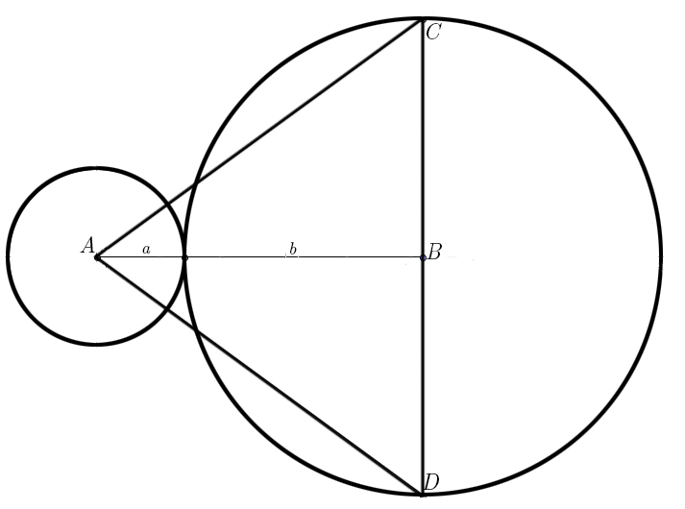

18) The only platonic solid with square faces is the cube.

19) “Unfold” the cube so that you have a net. You will notice that opposite vertices rest on opposite corners of a 4x8 rectangle. Then the distance from one point to the other is 

20) We know that . Either through recognizing that the requested sum is , or through algebraically arriving at our sum, we have that the answer is . Algebraically, add *E* to both sides, then subtract *V* and *F* from both sides, then subtract 2 from both sides.

21) The area of one of the bases is 4, since the volume is base*height and the height is given to be 4. Then by the area formula for hexagons, 

22) Since the hemisphere and cylinder have the same radius, our problem reduces to [hemisphere] + [cylinder] =  . After a bit of algebra, *h* turns out to be 7. Our total height is 7+4=11

23) The side length must be 16, and thus the area is 

24) Each straight segment has length 2, and there are 3 of them, giving us 6. Then, each semicircle has diameter 2. Then the circumference of the full circle is , but we want half that, so just . There are three arcs, so we have as our answer 

25) The radius varies linearly, and so does the circumference. Half way up means half the radius means half the circumference.

26) The perimeter can be attained by adding two of the sides to the length of the circular arcs. Each side is 4, and each arc has radius 2, so the perimeter is .

27) The complement of 31° is 90°-31°=59°. The supplement of 59° is 180°-59°=121°. 2*121°=242°.

28) Three consecutive angles must add up to exactly 180°, which means that , and we have , which means that *x*=32.

29) For part A, we have the sequence , which implies that . Similarly for B, we have the sequence , implying that  . Then 

30) The booths mentioned are Nathan’s, Nick’s, Jamie’s, Chase’s, Annie’s, Jason’s, Jessie’s, and Niral’s, for a total of 8 booths.